# INDUSTRIAL VISIT REPORT



**DEPARTMET OF TECHNICAL EDUCATION GOVERNMENT POLYTECHNIC, MOSALEHOSALLI, HASSAN COMPUTER SCIENCE & ENGINEERING DEPARTMENT**

**YEAR : 2024 - 25**

**SPECIALIZATION PATHWAY ARTIFICIAL INTELLIGENCE &MACHINE LEARNING**

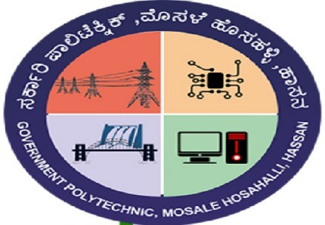

**VISIT PLACE: GOVERNMENT TOOL ROOM & TRAINING CENTRE**



**ON: 13-09-2024 SUBMITTED BY: NAME:CHANDAN C.S REG NO:189CS22006 SUBMITTED TO:**

## PRAVEEN KUMAR K

**Sr. Gr. Lecturer Dept. of CSE**

## PUSHPA H.P

**Dept. of CSE**

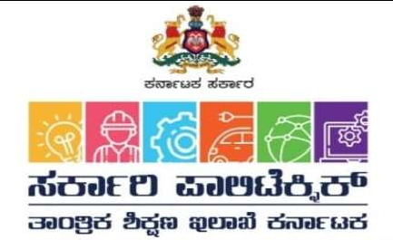

## GOVT. POLYTECHNIC MOSALEHOSAHALLI INDUSTRIAL VISIT REPORT

**GOVERNMENT TOOL ROOM & TRAINING CENTER**

**A Society of government of Karnataka**

**A complete report on industrial visit organized by collage GPTMH for the students of Computer Science & Engineering [5th SEM] in order to get the practical knowledge about “IOT LAB, Electrical Lab, Automation Lab, Mechanical Workshop & CNC Shop” carried out by Government Tool Room & Training Center[GTTC].**

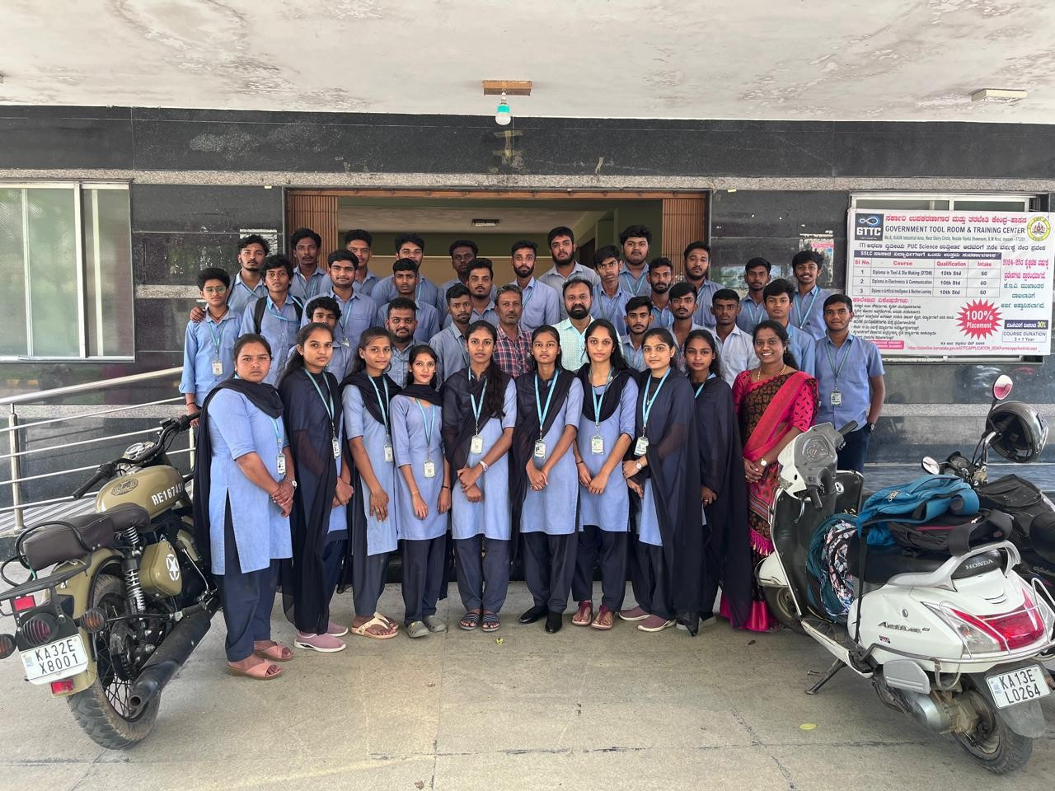

# COMPANY PROFILE:



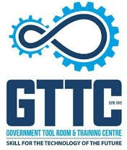

* GOVERNMENT POLYTECHNIC COLLEGE,MOSALEHOSAHALLI had organized an

industrial visit on 13 September, 2024 to GTTC located in DAIRY CIRCLE , HASSAN for the students of Computer science Engineering.

* The visit was organized by Praveen Kumar sir and Pushpa miss,Totally **36** students along with 2 coordinators faculty were there in the journey.
* The Government Tool Room and Training Centre (GTTC) in Hassan, Karnataka, is an institute focused on providing technical training and skill development in various engineering disciplines. Established to support the growing demand for skilled labor in industries, GTTC offers courses in areas such as machining, tool design, and fabrication.
* Proliferation of technology for development of the industries with supply of skilled manpower is the key to meet the needs of the global requirement. With this Government of Karnataka encouraged GTTC to start 10 more sub-centers to train in the area of tool and die making in various parts of Karnataka.
* GTTC is an autonomous society, and a recognized Scientific and Research Organization by the Government of India. Govt. Tool Room and Training Centre (GTTC), is serving industry by way of precision tooling and providing in well trained craftsmen the area of tool and die making.
* Fully aware of the rapid advancement in technology the world over, GTTC is periodically adding new technologies to the existing set of advanced equipment like CAD / CAM, CNC machines for tooling, Precision Components, Laser for Industries, Rapid prototyping, vacuum casting etc.

# GROUP OBSERVATION



* This Industrial visit is very helpful in our future practical
* Got practical knowledge about the advancement in technology of machines.
* Use of programming in field of Computer science engineering.
* Use of IOT and sensors in our future.
* Precise cutting and surface finishing of the jobs.
* Information on different parts & use of CNC machines with multiple cutting tools.
* Different types of machines available for tool & die making.
* Management of manpower and machines.
* Grinding machines and milling machines in mechanical workshop.
* Machines that work based on plc.

**What we learnt in IoT lab :**



**IoT**:

The Internet of Things (IoT) refers to a network of physical devices, vehicles, appliances, and other physical objects that are embedded with sensors, software, and network

**Sensors**:-

**Sensor is an element which produces a signal relating to the quantity being measured.**

* An input device which provides an output (signal) with respect to a specific physical quantity.
* A device that converts signals from one energy domain to electrical domain.

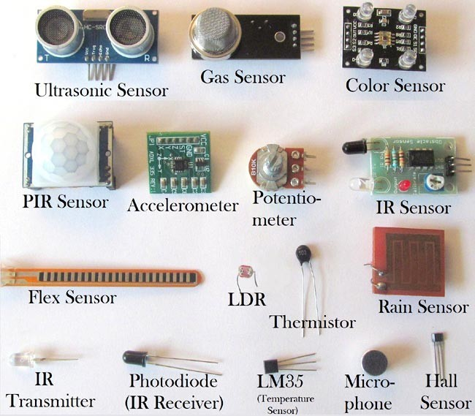

# WHAT WE LEARNT ON AUTOMATION LAB:



**Process Instrumentation Trainer**

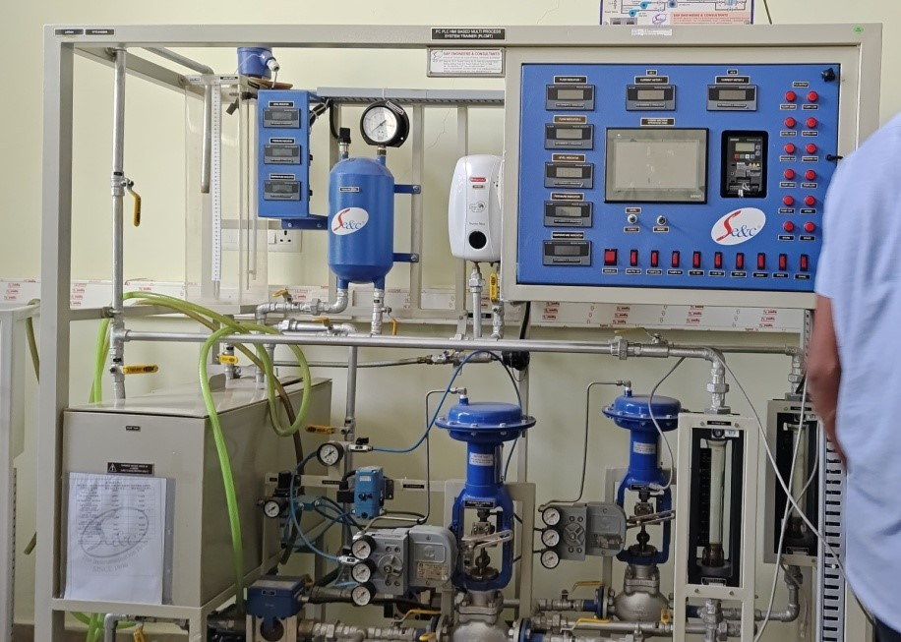

* + **Nematic trainer system**

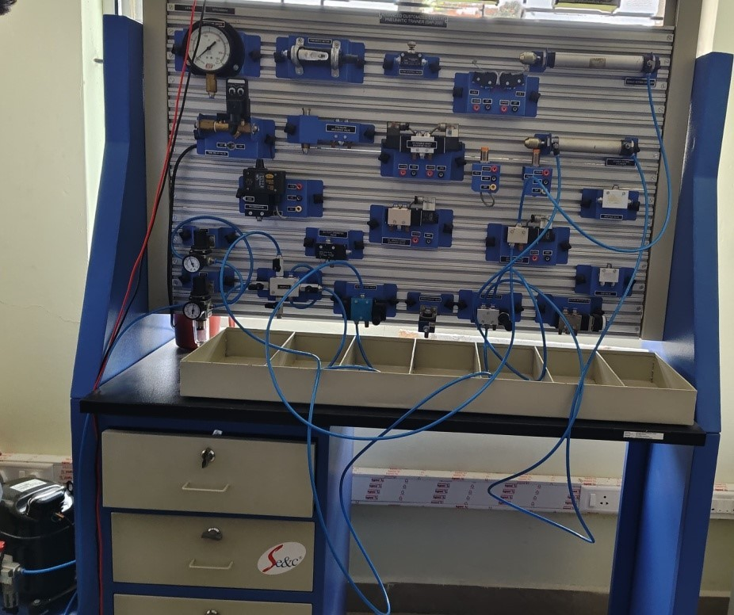

* + **Batch processer rector system**

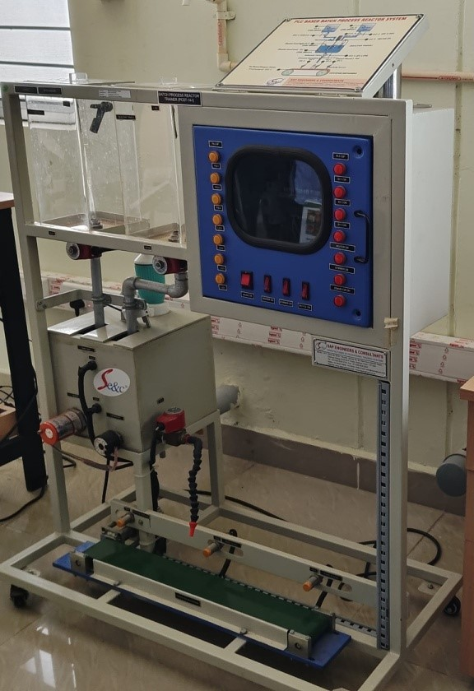

* + **CNC Machine**



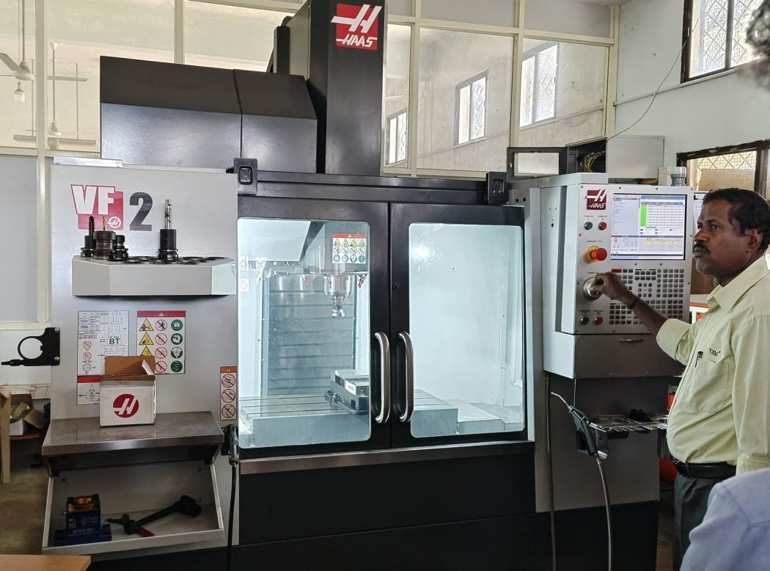

* + **Premiere Work Station**

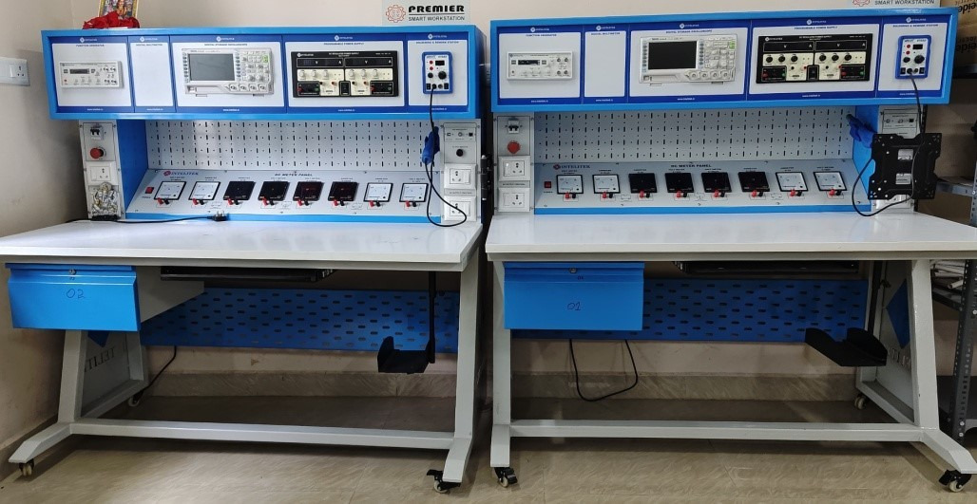

**CONCLUSION:**We are thankful for all our faculties for organizing such an Informative event for development of our practical skills regarding tool & die making & other activities.We got the knowledge on different types of machines used in GTTC and had an opportunity to research on it.We hope to get more chances further to have such an informative & wonderful experiences of visiting different industries.

